**LAB 07 AND 08**

**(Show input and output side by side for all problems)**

1. **Detect** the tumor from the images using the segmentation approaches listed below:

(Outline the segmented object to highlight the tumor. You can crop the image for

accurate segmentation.)

i) Similarity approaches:

a) Local/Regional Thresholding

b) Global Thresholding

c) Variable Thresholding

d) Dynamic/Adaptive Thresholding

ii) Discontinuity approaches: Edge Detection (Sobel, Canny, Prewitt)

2. **Show** in a table how the Similarity and Discontinuity techniques compare.

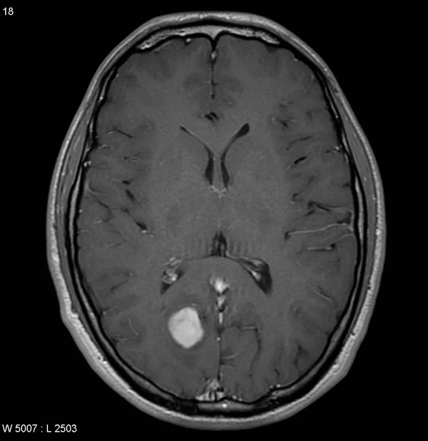

**Figure 1:** Tumor -1

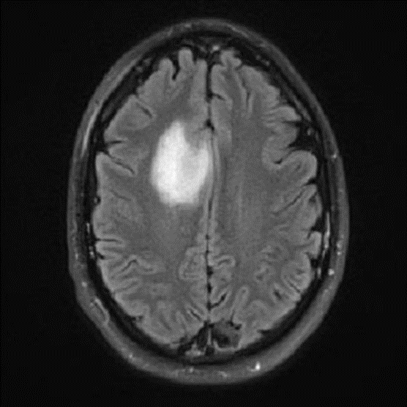

**Figure 2:** Tumor-2

***(Show input and output side by side for all problems****)*

3. Generate a binary mask of the tumor from Figure 1 using any segmentation method of your choice, then apply:

i. Morphological Dilation

ii. Morphological Erosion

By using appropriate structuring element on the mask.



**Figure 1:** Tumor

4. **Apply** the Hough transform to Figure 2 and draw the detected lines on the original image.

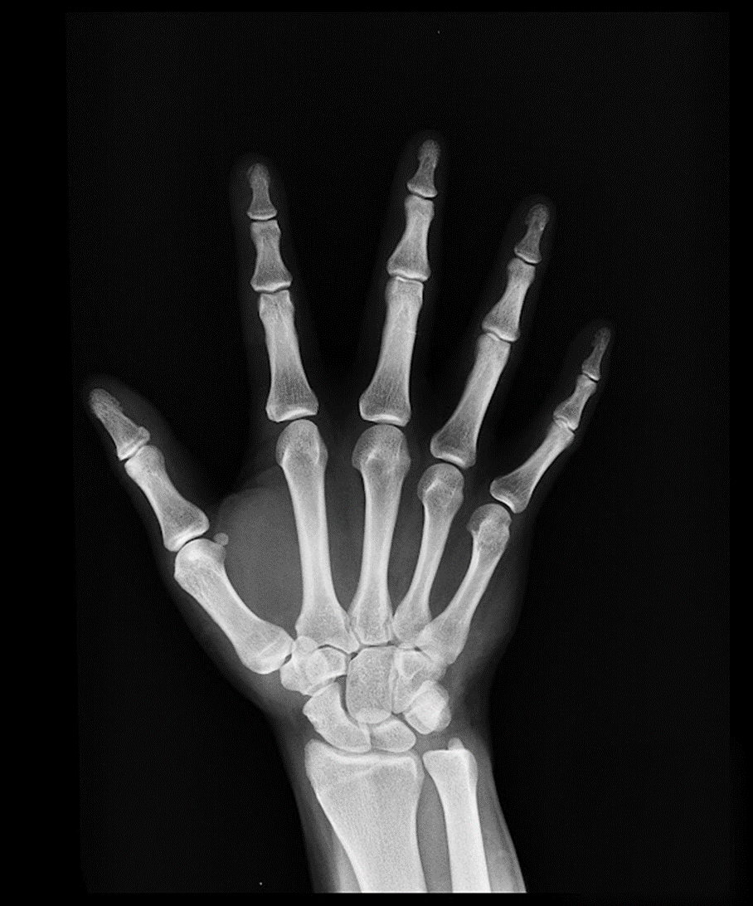

**Figure 2:** X-Ray Image